The Title of the Manuscript Maximum Twenty Word

Author firstname(space)Surname^{1*}, Author firstname(space)Surname²
¹Affiliation Program, Faculty of Affiliation, University of Affiliation, Affiliation address, Street no. City.
²Affiliation Program, Faculty of Affiliation, University of Affiliation, Affiliation address, Street no. City.
*Corresponding author: username@domain.com Whatapps number:...(only for disscussion)

Received:  Received in revised:  Accepted:  Available online: | Abstract
The abstract should be self-contained and citation-free and should not exceed 200 words. There are 4 components must contain within the abstract i.e. research aim, methods, brief results and conclusion.
Keywords: Up to 5-7 words

INTRODUCTION
This section should present the background of the research conducted, other studies that support (Spellman, 2013), this research is conducted which is new from the research conducted. The use of cited literature (Sutapa, Rosmawaty, & Samual, 2013), does not include literature that is not in the bibliography. It is not permitted to display figures and tables in this section (Bandjar, Sutapa, Rosmawaty, & Mahulau, 2014; Diop, Ben Talouba, Balland, & Mouhab, 2019; Sutapa et al., 2013)
METHODOLOGY
Materials and Instrumentals
This section must display the equipment (brand, specifications, and operating conditions) as well as the materials used (complete with the manufacturer).
Methods
This section must also be able to provide complete procedural information so that it can be carried out by other researchers who will be returning. All procedures that have been used must use international standard units and terms that are commonly used in scientific research.
Data Analysis
The equation used must be written centered with the numbering as in the following example:

(1)

RESULTS AND DISCUSSION
Subsection of Results
This section must display and explain the results of research obtained in a comprehensive manner. This section must be written systematically and can explain "What was done", "Why was done", and "How was the result". The picture obtained from the research results must be displayed as in Figure 1 and 2 (Aoyama, Aoki, & Sumita, 2021).

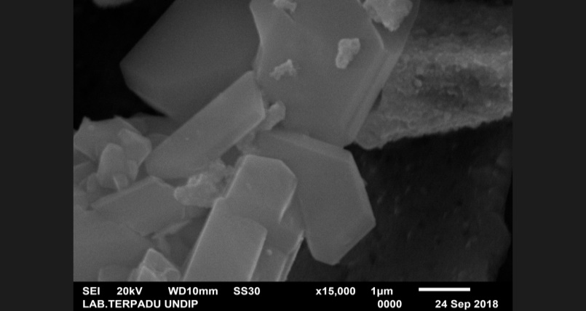
Figure 1. Title centered (Min. 300 dpi)

Figure 2. Title centered

The results obtained from the research carried out are shown as in Table 1.
Table 1. Caption of table
Methyl ester | Percentage (%)
methyl palmitoleic | 0.04
methyl oleic | 14.03
methyl palmitolenat | 0.22
CONCLUSION
Conclusions must be presented briefly and clearly that describe the results of the research obtained. Make sure the conclusions match the research objectives. Conclusions are arranged in paragraphs rather than in numbering.
ACKNOWLEDGMENT
All Acknowledgments must be conveyed (if any) to the contributing parties, aid providers (complete with contract numbers), and other parties who participated in the preparation of this article.

REFERENCES

Aoyama, T., Aoki, M., & Sumita, I. (2021). Effects of constituents in paste on low light performance of silicon solar cells: A case study of aluminum. AIP Conference Proceedings, 2367(1), 020002. https://doi.org/10.1063/5.0056075
Bandjar, A., Sutapa, I. W., Rosmawaty, R., & Mahulau, N. (2014). The Utilitasion of Beef Tallow Into Biodiesel With Heterogenous Catalyst. Indonesian Journal of Chemical Research, 2(1), 166–170.
Diop, A., Ben Talouba, I., Balland, L., & Mouhab, N. (2019). Thermal characterization of a biodiesel nitration: Bio-additive’s synthesis by calorimetric methods. Thermochimica Acta, 673, 138–146. https://doi.org/10.1016/j.tca.2019.01. 024
Spellman, F. R. (2013). Handbook of Water and Wastewater Treatment Plant Operations.
Sutapa, I. W., Rosmawaty, R., & Samual, I. (2013). Biodiesel Production From Bintanggur Oil (Callophyllum inophyllum L.) Using Calsium Oxide (CaO) Catalyst. Indonesian Journal of Chemical Research, 1(1), 53–60.

Note:

Reference has minimal 15. It is expected that 75% of references are to recent papers (no more than 10 years).

Manuscript with citation and reference not according to template will reject.

References should using references manager (zotero,endote, mendeley etc)

The references style : American Psychological Association, 6th Edition

The whatsapps number needed only for discussion (The publisher doesn't share your contact number with anyone)

